
NAME:M.MANIKANDAN
REGNO: 124012022053
B.TECH CSE(AI & ML)
SECTION:C
SUBMISSION DATE:2/11/2025

Conveyor Belt Monitoring
In a smart environment of management, control and industrial automation, one of the key elements to anticipate failures and increase productivity is to be able to monitor the status and use of conveyor belts of any kind of sector, whether it is for logistics or manufacturing. Thanks to the data obtained, the behavior of the belts can be studied (dilatation, deterioration, irregular advance…) thus creating patterns that allow to detect failures in the process. This way, it is possible to optimize the maintenance of the conveyor belts, increasing productivity and reducing the problems arising from the wear and tear of the machines.

Device: MTX-IoT, 4G IoT programable modem
Platform: IoT Platform
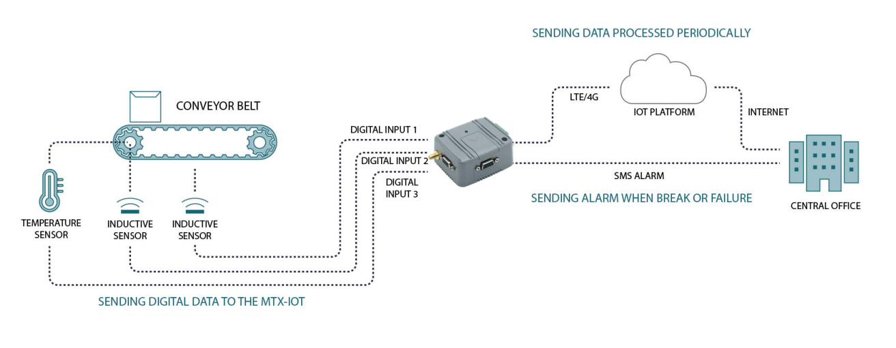
To obtain data, two inductive sensors detect metallic objects and calculate the distance between them based on the speed and frequency of detection. The first one is placed so that it can detect the movement of the conveyor belt itself. The second one is placed in the rotor. Thanks to these two independent measurements it is possible to detect if both elements are synchronized or if there is a speed difference between them, which could indicate a malfunction of the belt or an excessive weight supported (similar measures, but below the usual average). The selected connectivity equipment should have enough capacity for three independent digital inputs and processing ability to capture the data, store it and analyze it thanks to an algorithm that allows to detect anomalies directly, allowing to send an alarm if something breaks before even sending the data to the IoT platform. Due to these requirements the solution is designed with an MTX-IoT, an IoT modem with up to 3 digital inputs. The MTX-IoT, in addition, sends the data already processed in pre-recorded timestamps to an IoT platform, which adds another complex layer of processing that allows analyzing the patterns in the behavior of the conveyor belts to foresee their deterioration. The solution also includes a temperature sensor located next to the conveyor belt motor to monitor the operating temperature and detect overheating or abnormal temperatures. This information is also processed to send an alarm if the temperature is outside the range, and it’s also stored and analyzed in the IoT platform.

ICU Patient Vital Signs Monitoring System
Introduction
The Intensive Care Unit (ICU) is a specialized area of a hospital that provides care to patients with severe or life-threatening illnesses and injuries. This area requires constant and close supervision from life support equipment and medication to ensure normal bodily functions (National Health Service, ). A continuous physician supervision is recommended for patients under these conditions, however, treating physicians cannot remain in the ICU unit all the time to take care of these patients. Instead, resident doctors remain in the area to constantly monitor each patient. In the event of an emergency, resident physicians should contact the treating physicians, either by using a communication devices (e.g., phone or beeper) or by personally searching for them, leading to higher response time in emergency cases
• Data accuracy: A margin of error should be established for the data measuring. In this particular case, health measures must be very precise since the slightest difference can have a serious or unwanted impact.
- Availability: The system is used by different users who have different access roles and requirements, and therefore, must be available to all users anytime, anywhere.
• Performance: The system should offer a satisfactory performance to end users. The response time in all procedures should be as low as possible.
• Data privacy: The privacy of health data must be protected for all users, especially those under critical monitoring. The system should provide a proven mechanism to ensure privacy
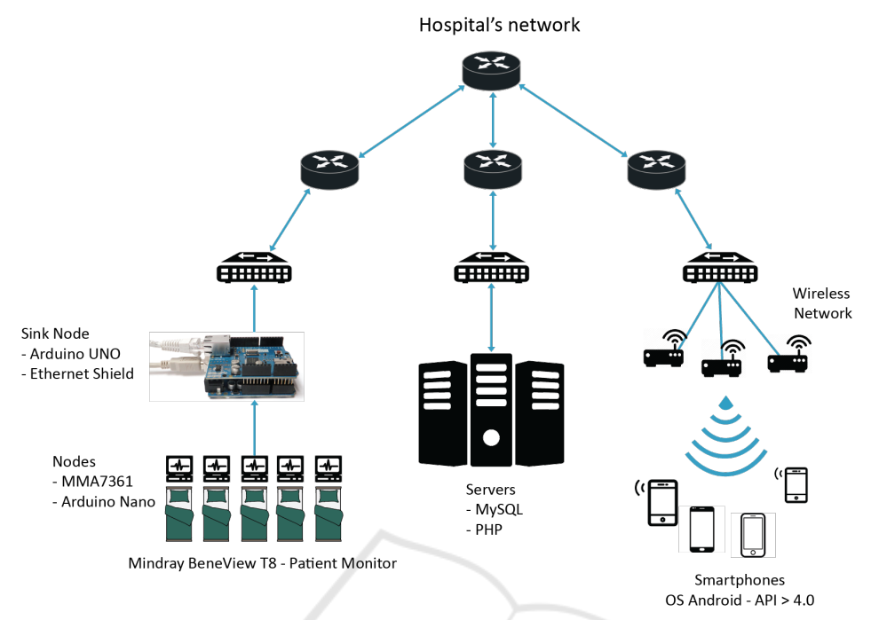

System Architecture
The above figure presents the top-level architecture of the proposed ICU automation system. The architecture consists of a Sink Node that is connected to the back-end server using the Local Area Network (LAN). The existing infrastructure provides a WiFi physical layer to connect the smart devices or phones to the local network. The intranet is also connected to this WiFi network. Thus, these devices provide the primary human machine interface for the nurses, doctors and other staff. The server has its own database and application servers and MySQL is used as the Data Base Management System (DBMS) engine while Apache provides the application server functionality. The application is Web-enabled, which requires only a standard browser at the client side. The first module is composed of the sensors deployed on the beds. These sensors are connected to a gateway designed with an Arduino UNO and an Ethernet Shield, connected directly to the hospital’s internal network where the data is transmitted and stored in the MySQL database. In addition, each patient has a monitor connected directly to the hospital network, which provides their vital signs and stores this information in a proprietary database. The second module consists of a PHP-based server based and a MySQL server. The server contains several scripts to perform search, add or update information in the database when a request is received from the mobile application. The third module is a mobile application that allows physicians to visualize patient data.

Conclusion:
I presented an innovative system that enables the medical staff to check and analyze the vital signs of ICU’s patients from distance, having a constant control of them. Pop-up notifications alert the response team if one or more patients have a significant change of vital signs. This allows the medical team to react quickly and apply the appropriate treatment. The database access table helps the hospital management team to control and protect patient data. This also helps the system provide a hierarchically controlled alert. The resources required for mobile application allows it to be run in low-mid range and higher phones. The application design facilitates the training period its users, which helps the users’ work environment. As future work, we plan to make the system more functional, allowing to establish relationships between several parameters and obtain more accurate information about the patient’s condition. Patients’ data from the system could be analyzed with the machine learning algorithm to predict their status and reduce the generation of emergency notifications to the cases where the presence of the main doctor is really necessary.

References :
Wikipedia
Britannica

